Haemoglobal

End User Manual:

1. Install .apk file on your mobile.
2. Choose your choice (Consider registering)

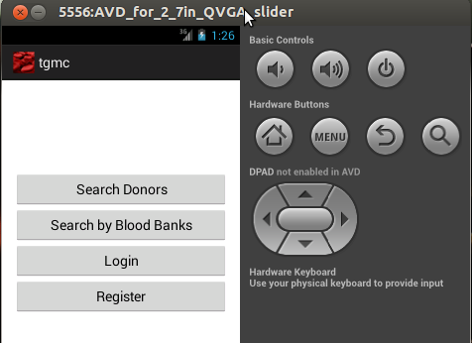

1. Register with correct details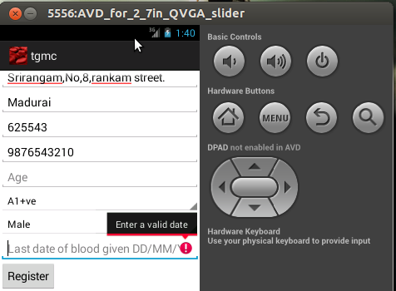
2. Click register button after inserting correct details. Your details will be stored in the Server and your name will be displayed to a person if they searches your blood group in your city.

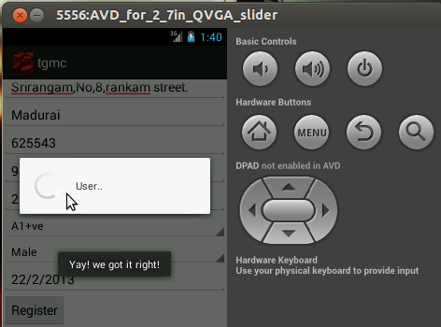

1. Search donor by clicking on home button in home screen. Give the necessary details for searching a donor. 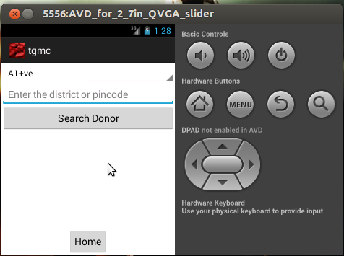
2. After clicking search donor button the result of donor will be viewed in the list.

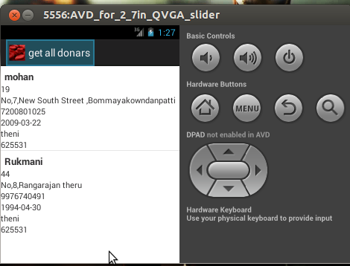

1. If the user search by blood banks then the blood banks details will be displayed.

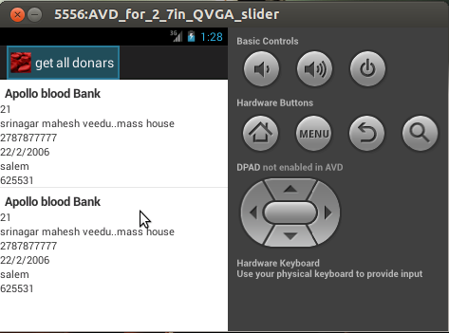

1. User can send the details of the donor by long pressing the item and selecting a contact the message will be sent to the contact.
2. User can login by clicking on login button in home screen.

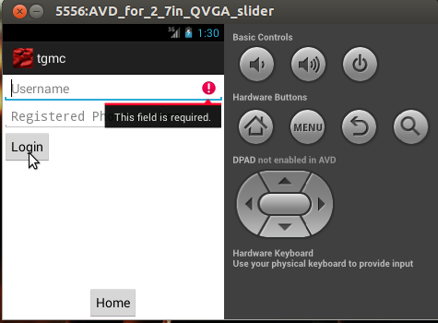

1. After logged in with the user information the person can update his details ie: Last date of donated blood will be changed.

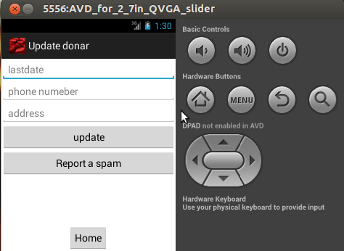

1. User can report a spam user by clicking on the report spam button on the update screen.



1. Consider the user is blocking person “arun” so the “arun”s blockrate will be increased by one. And arun will be removed from the database if his block rate reaches 3.

